4-Port USB 3.0 Hub Super Speed with Individual LED Power Switches for for Macbook, Mac Pro/mini, iMac, Surface Pro, XPS, Notebook PC, USB Flash Drives, Mobile HDD, and More
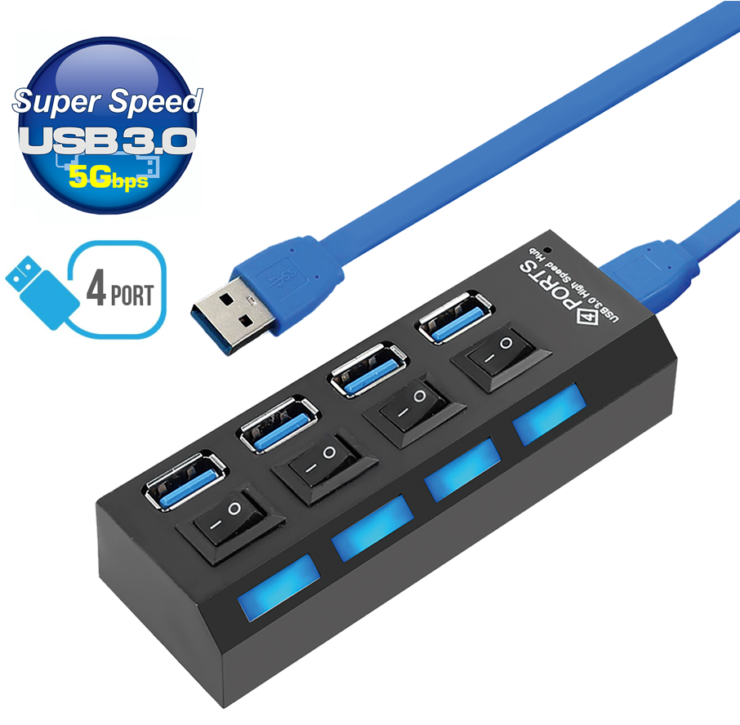

About this item
✔️ SUPER SPEED UPTO 5 Gbps | Sync data at super speeds up to 5Gbps fast enough to transfer movie, photos, documents in seconds.
✔️ STURDY COMPACT DESIGN | Precision-designed for heat resistance and incredible durability. With power switch you can turn on and off any port.
✔️ NEED FOR EXTRA PORT | Transform one of your computer's USB ports into four.
✔️ MULTIUSE USB 3.0 HUB | Connect up to 4 USB devices, e.g. Memory sticks, hard disk, mouse, keyboard, printer, digital cameras, camcorders, speakers, scanners, card readers etc. with simple plug and play installation
✔️ 100% SATISFACTION GUARANTEED: We strive to provide quality products and service. While our products are made of high-quality material, should you have any issue with your purchase, we Provide a 2-year warranty. Feel free to contact us. Your happiness with your purchase is our #1 priority!

Ideal for connecting both SuperSpeed USB3.0 (5Gbps) and your existing USB2.0 (480Mbps) devices into one, convenient Hub. Ideal for when your WindowsTM, MacTM or any other device has only a limited number of SuperSpeed USB3.0 ports.
Connect with ease almost any USB device such as external storage devices, memory card readers, cameras, printers, scanners and a whole host of input devices with total simplicity.
Fully Plug n' Play for all popular operating systems such as WindowsTM, MacTM, LinuxTM and more besides.

SPECIFICATIONS

4-Port SuperSpeed USB3.0 Hub

4x downstream ports, 1-upstream port

5Gbps transfer speeds: Backward 480Mbps compatible

Tri-compliance: USB3.0, USB2.0 and USB1.1

Fully Plug n' Play, no drivers needed

Integral USB surge protection - protects attached USB devices

Integral LED status in a compact, stylish design

Package Dimensions ‏ : ‎ 9 x 5 x 5 cm; 97 Grams

Part number: USB3-HB-4PM-V

